MODULE 2
1. Conditional Statements in C | HackerRank
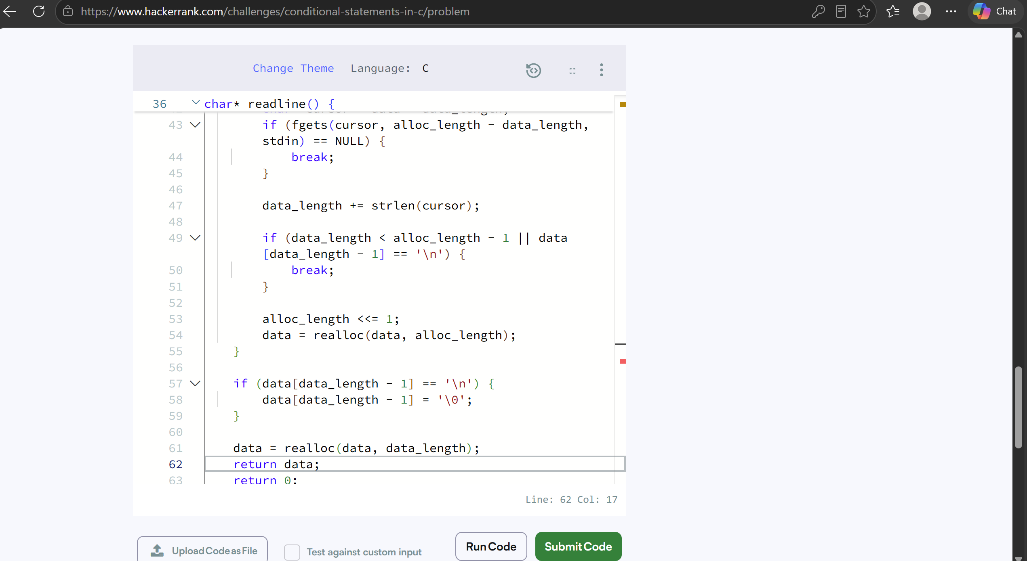
2. https://leetcode.com/problems/smallest-even-multiple/description/

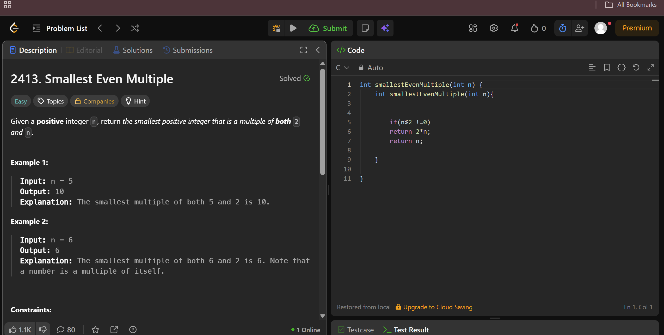
3. https://www.hackerrank.com/challenges/grading/problem

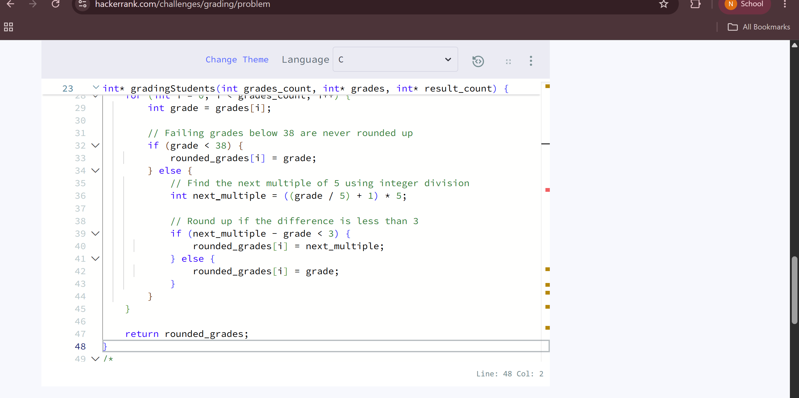
4. https://www.hackerearth.com/practice/basic-programming/input-output/basics-of-input-output/practice-problems/algorithm/roy-and-profile-picture/

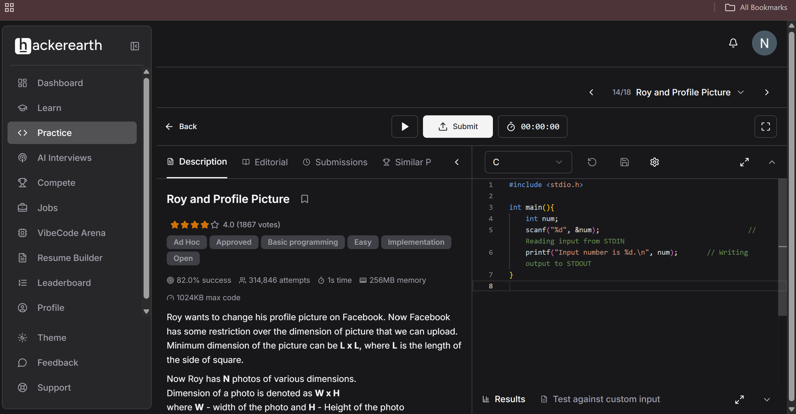
5. https://leetcode.com/problems/fizz-buzz/description/



